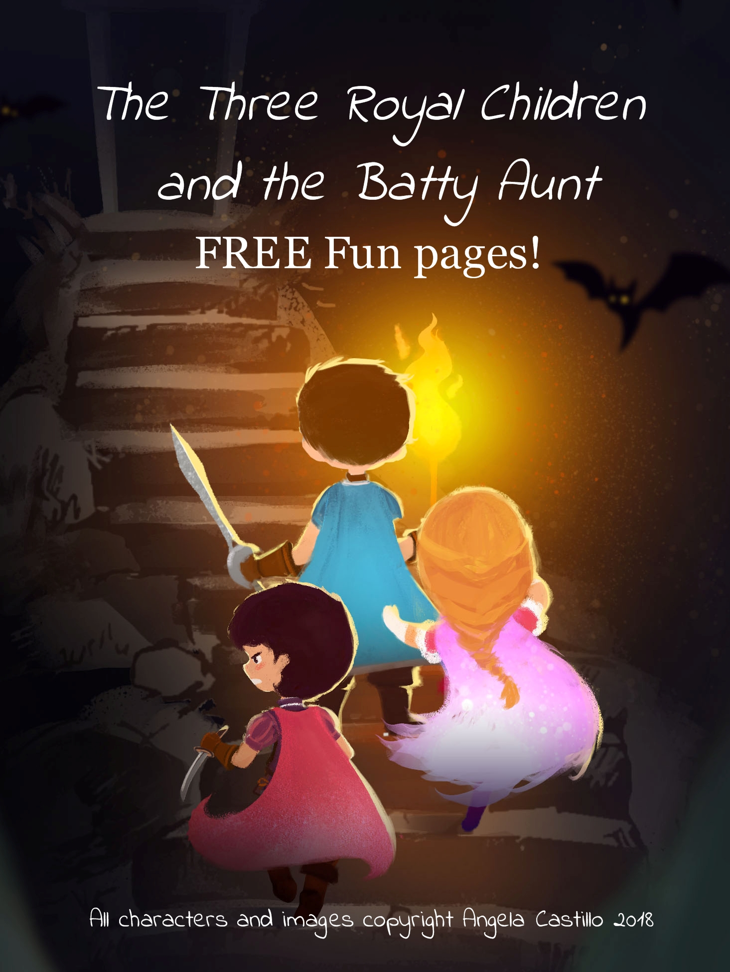
Color Princess Celeste, Prince Torrin and
Prince Jude so they will be ready for adventure.
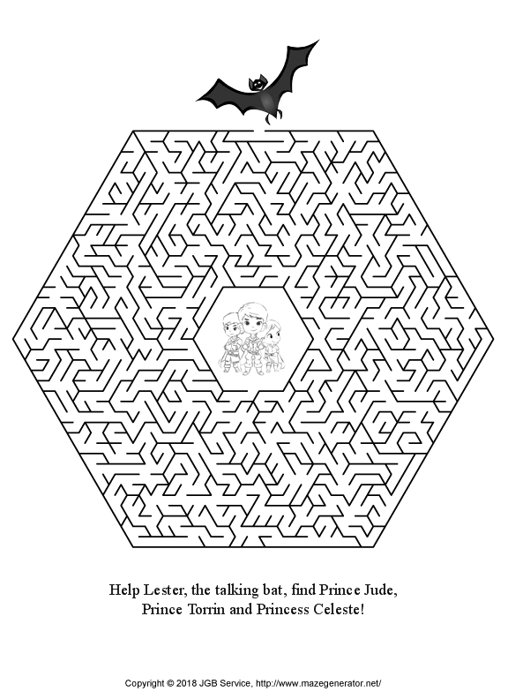
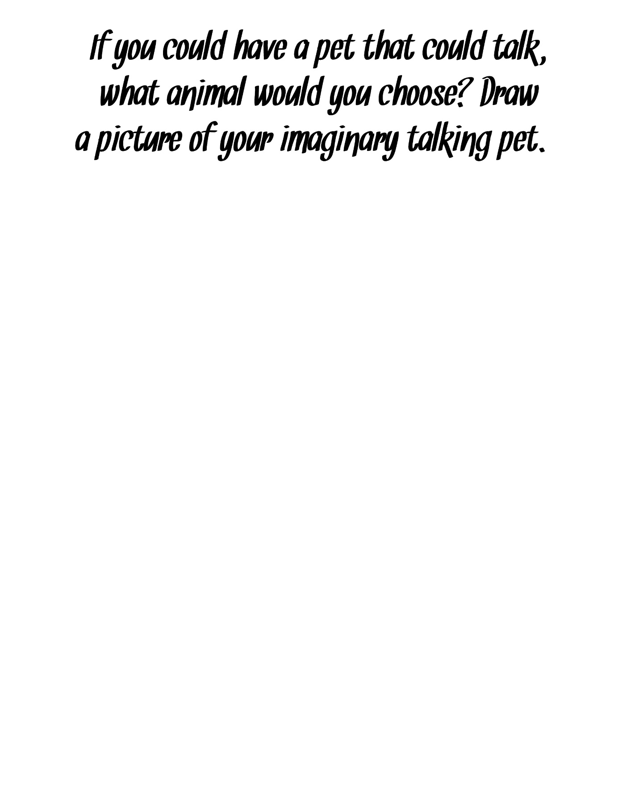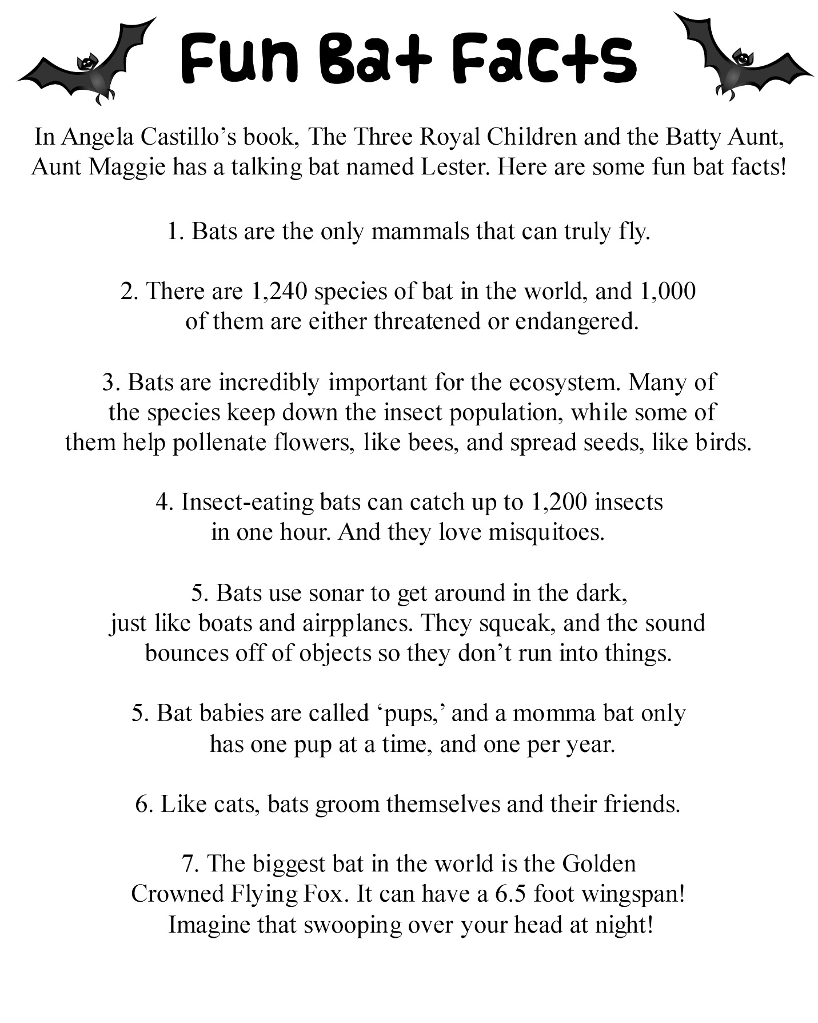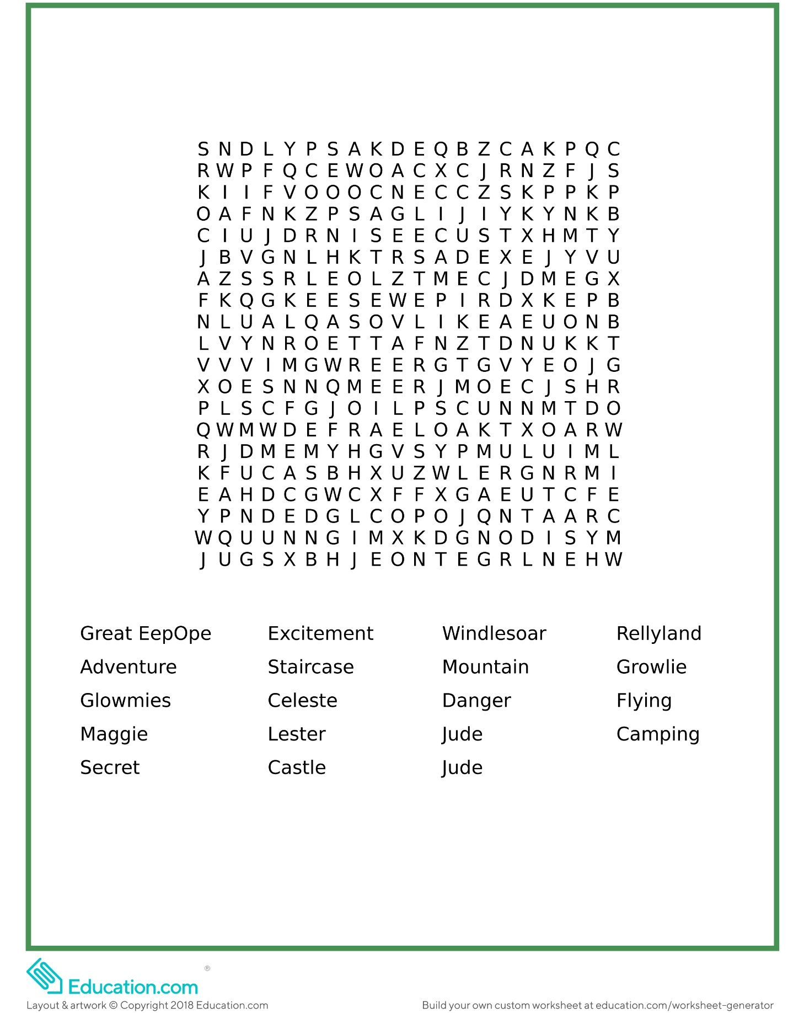
Find all the words from the book
The Three Royal Children and the Batty Aunt.
Thank you for coming to play! Remember, you can get a copy of Angela Castillo’s exciting new book, The Three Royal Children and the Batty Aunt on Amazon.com here: https://amzn.to/2J9Jutk for Kindle or in paperback! Find out more about Angela’s writing at these links:

Angela’s Amazon Page
https://amzn.to/2CZSXTY

Angela’s Website for Kid’s Books
https://tobythetrilby.weebly.com/

Angela’s Kid’s Books Facebook Page
https://bit.ly/2q1G4jR

Sign up for Angela’s newsletter to find out about contests, new books, and more!
http://eepurl.com/dKv4xQ

