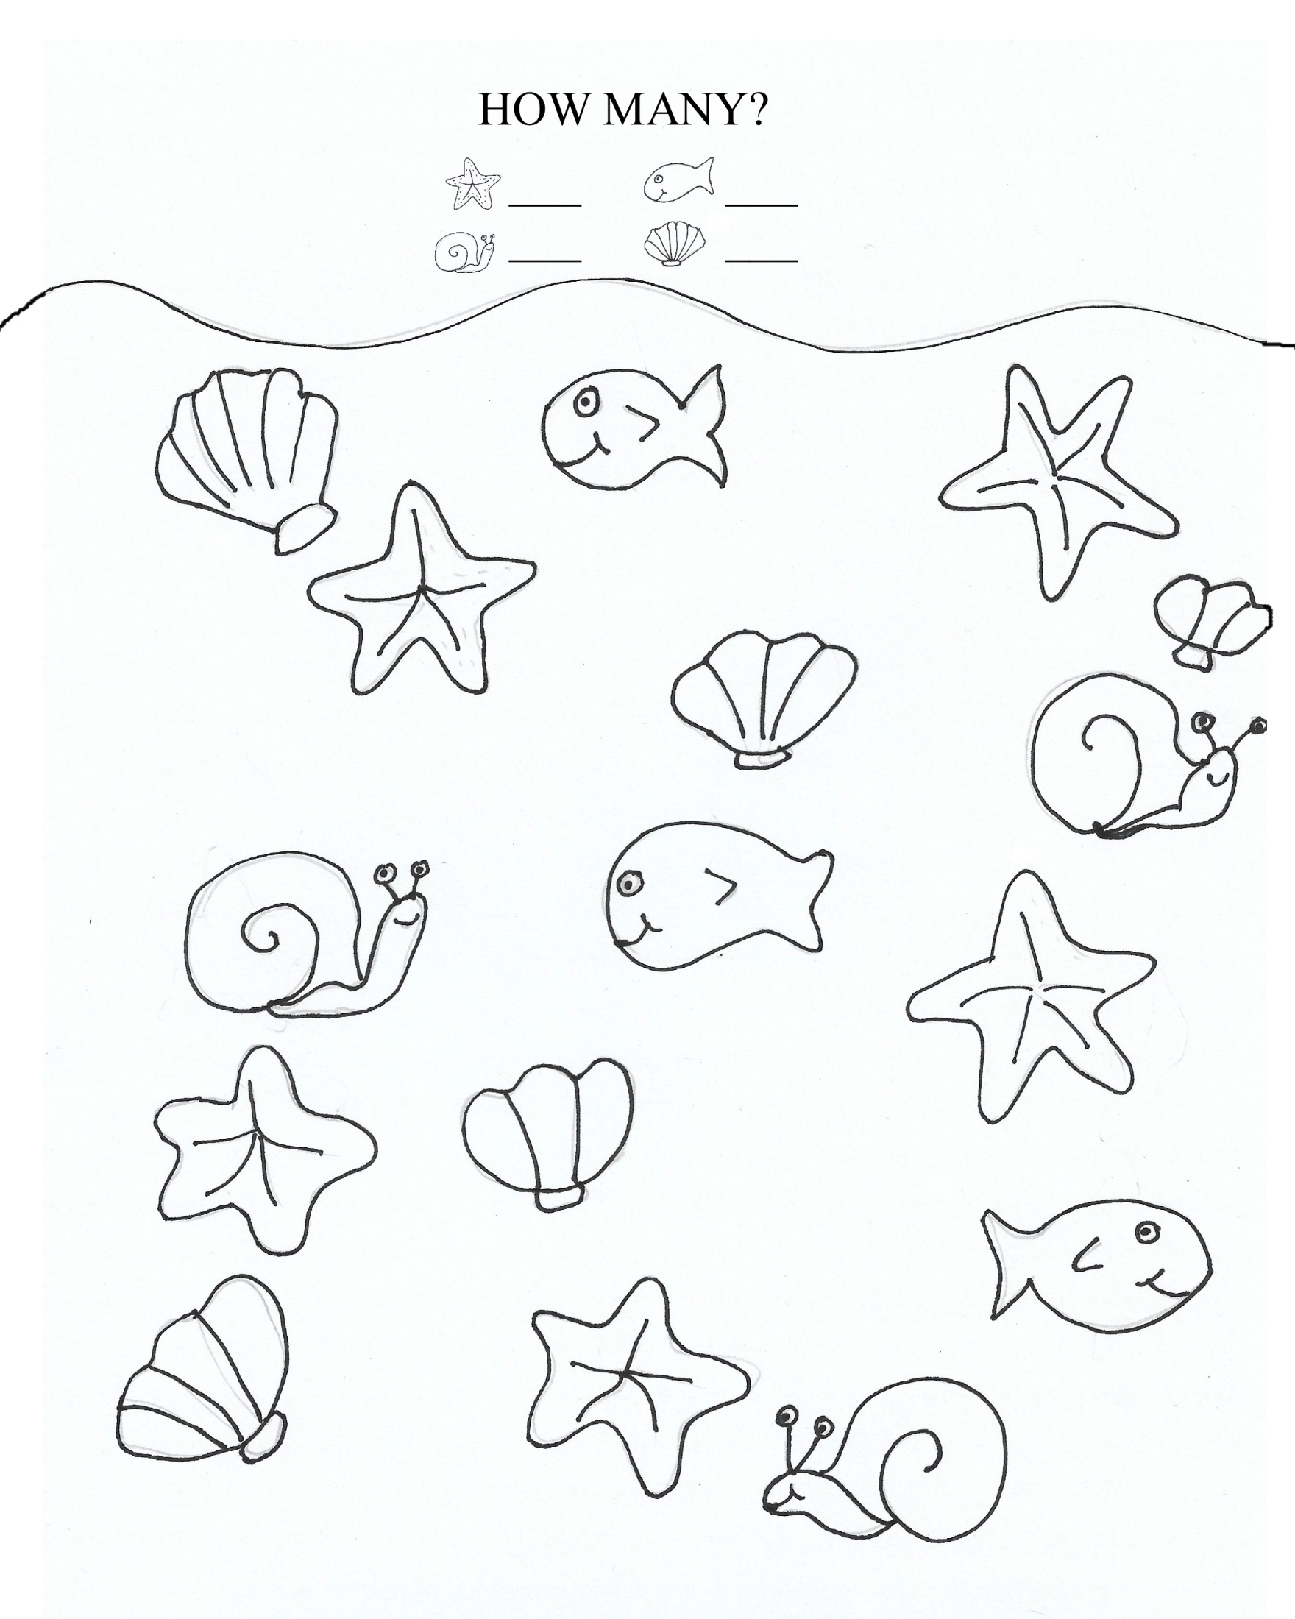

WORD FIND
Z | A | A | L | Z | E | M | K | U | J | Y | B
L | W | A | C | I | T | C | R  Z A A L Z E M K U J Y B  L W A C I T C R A D C R  L W G X E O O N O N O R  G Q U K L E C O R A L W  K P L B T W V E L Y D O  O C E A N E H R A A Q G  E C B P E T L A H L Y A  I W P C R F I D W A D B  M A E O O H G Y R E X J  Z V N X P I H V A S C R  J E E H A F T E N S E T  W S T E R N S I T M E C | A | D | C | R
L | W | G | X | E | O | O | N | O | N | O | R
G | Q | U | K | L | E | C | O | R | A | L | W
K | P | L | B | T | W | V | E | L | Y | D | O
O | C | E | A | N | E | H | R | A | A | Q | G
E | C | B | P | E | T | L | A | H | L | Y | A
I | W | P | C | R | F | I | D | W | A | D | B
M | A | E | O | O | H | G | Y | R | E | X | J
Z | V | N | X | P | I | H | V | A | S | C | R
J | E | E | H | A | F | T | E | N | S | E | T
W | S | T | E | R | N | S | I | T | M | E | C

CORAL COLD NORTHERN LIGHTS TERN BELUGA ICEBLOCK ARCTIC FOXES OCEAN SEAL WAVES

Word Scramble:
unscramble the ocean words.
- HLLES _ _ _ _ _
- PUTOOSC _ _ _ _ _ _ _
- CRAO _ _ _ _
- TWARE _ _ _ _ _
- CIE _ _ _
- LGEABU _ _ _ _ _
- NSOW _ _ _ _
- LOPRA REBA _ _ _ _ _ _ _ _ _
- ISFH _ _ _ _
- OENAC _ _ _ _ _

