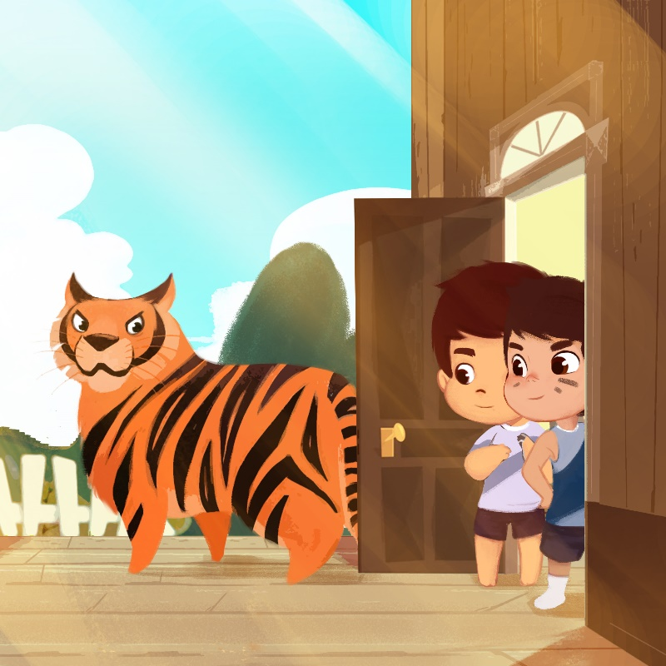

(These questions are for “Tigers Can’t Open Doors” by Angela Castillo)
Question Time!

1. Do you think the shape-shifting monster was real or imaginary? Why or why not?

2. Do you think the boys had good ideas to get away from the monster’s different shapes?

3. Have you ever been afraid of something?

4. Have you ever had a time where you had to solve a problem?

5. What did you do?

6. Have you ever had to ask an adult for help?

7. Did the adult help you?

